1. 
2. Local Transaction allows Producer to write to multiple Kafka Topics atomically.
3. 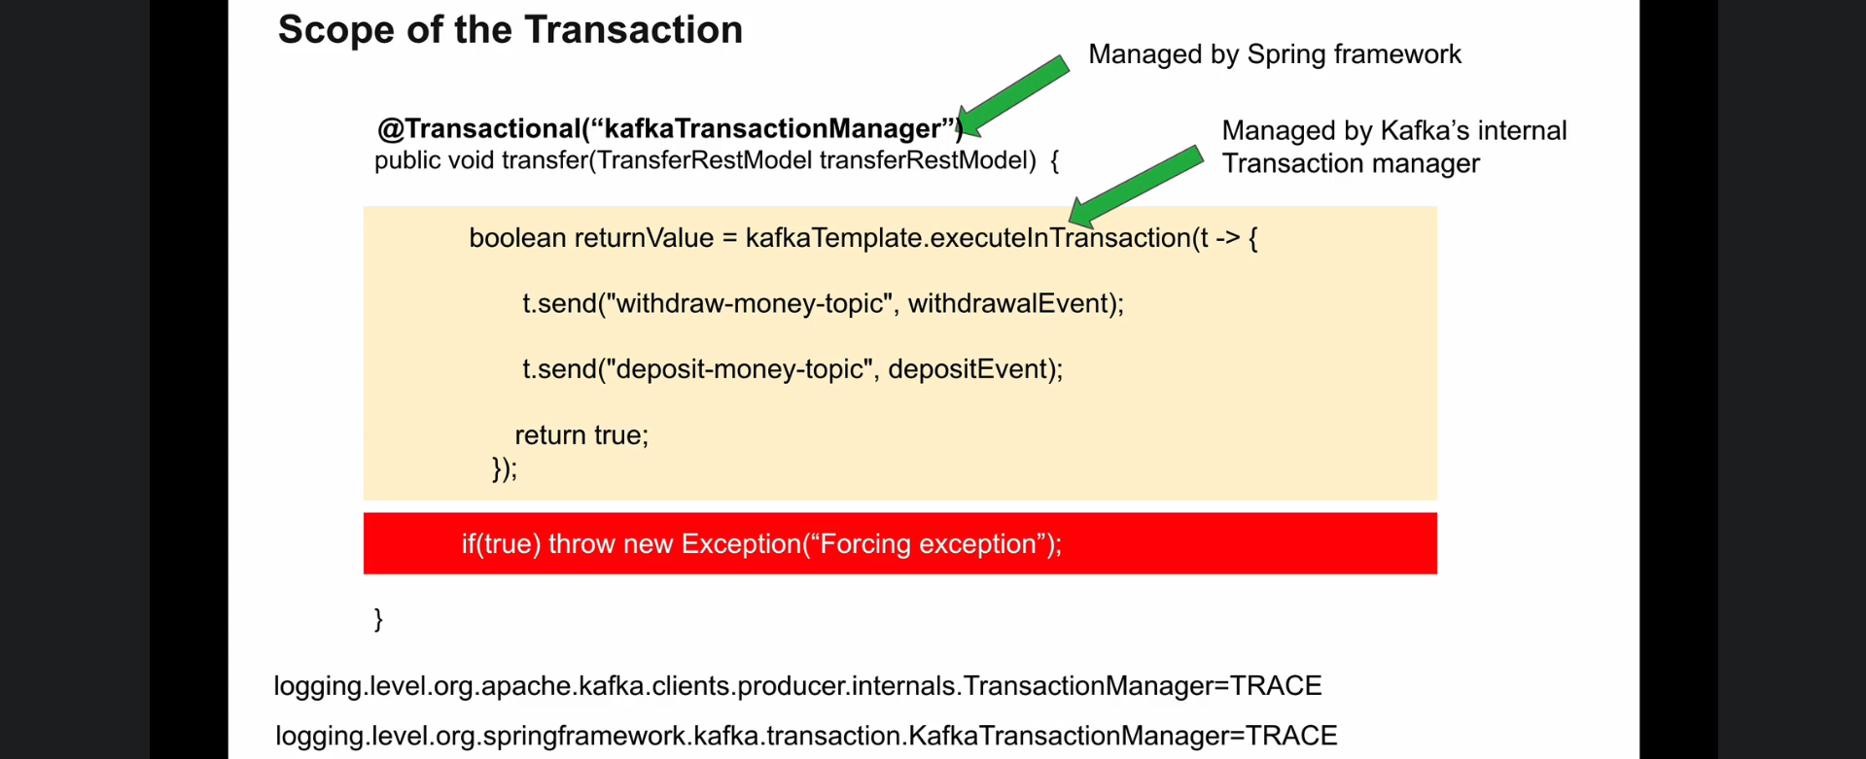
4. 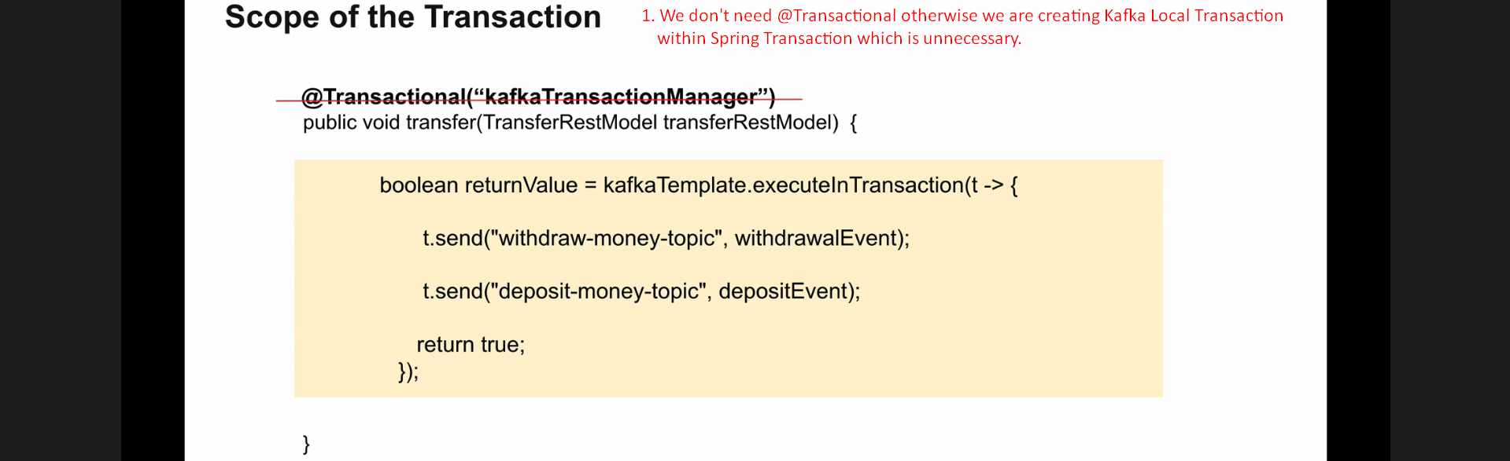  
   **Jatin**: I think it is called Local Transaction because It can not span across multiple method calls whereas @Transactional may contain other method calls and if any one of them throws exception, we may perform the rollback.